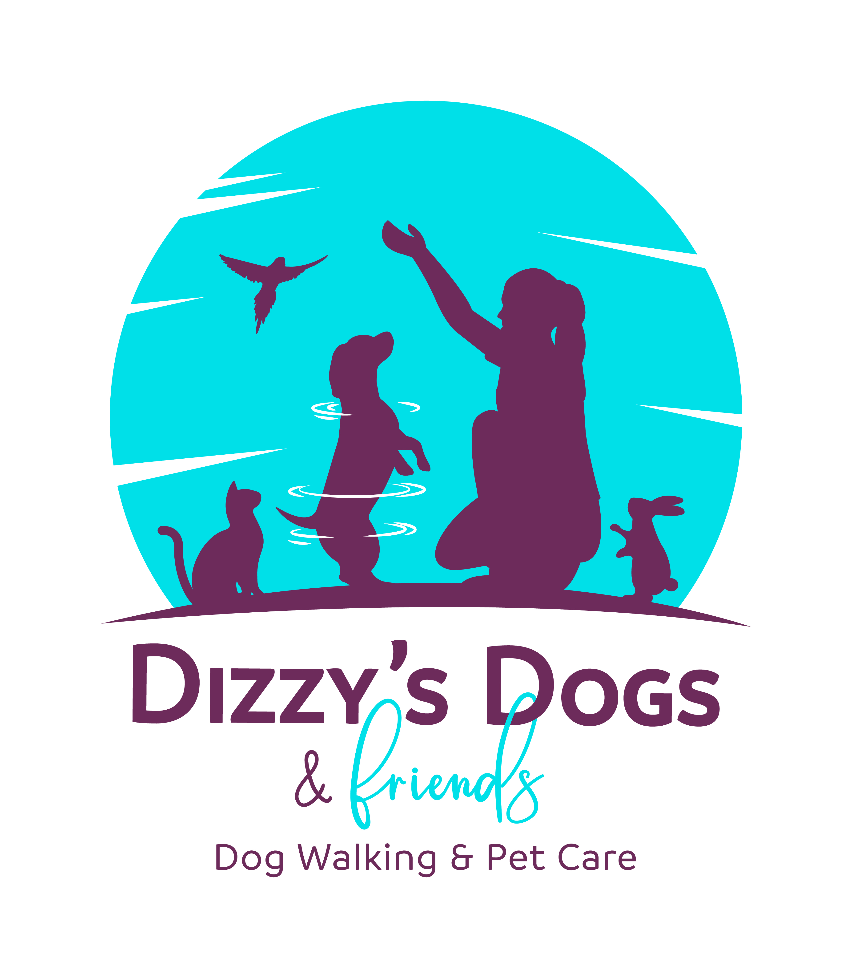

**Terms & Conditions**

Please read through the Terms & Conditions thoroughly to make sure you are happy with everything. This will need to be signed before we start work.

**Dizzy’s Dogs & Friends** are fully insured and DBS checked.

**Payment**

* Dizzy’s Dogs & Friends will send an invoice following the service. Payment is to be made by bank transfer using the bank details on the invoice.

**Keys & Security**

* Dizzy’s Dogs & Friends label keys with your Pet(s) name. Keys are kept at my house in a locked Key box overnight. If you prefer to use a secure key box at your home, I will keep the code details with your pet(s) name attached.
* Alarm or gate codes will also be kept securely with your pet’s name attached.
* Keys needed for the day will be kept securely attached to my person at all times.

**Cancellations & Holidays**

* If you need to cancel a walk or visit, please let me know as soon as you are able to. I understand things can change at the last minute, but regular last-minute cancellations will be charged.
* I will advise you as far in advance as possible of any holiday dates or dates I am unable to work.

**First Aid & Welfare**

* I have completed a Pet First Aid Course and a Dog First Aid Course and have a Pet First Aid Kit with me at all times. Following any First Aid Treatment you must take your pet to the vet for a check-up.
* I keep an accident book to record any incidents that have taken place. Any First Aid Treatment given to your pet will be recorded and you’ll be given a copy of the details and asked to sign it.
* Health issues, including allergies, must be declared on the booking form, along with emergency/vet contact details.
* In case of emergency I would attend the nearest vet to me if this means getting your pet seen by a vet more quickly. Any emergency treatment and any treatment following will be paid for by the owners.

**Walking**

* In line with current law, all dogs must be microchipped and wear a collar and tag with contact details and postcode. In addition, all dogs will wear a Dizzy’s Dogs & Friends tag whilst being walked with my contact details on.
* Dogs must be up to date with required vaccinations, flea and worm treatment.
* I will let dogs off lead only when the owner has agreed, and only if I have built up a relationship with your dog and recall commands have been discussed.
* If I see any behaviour whilst your dog is in my care that I feel is potentially dangerous to another dog or human I will share this with you and depending on the outcome I may not be able to continue working with the dog.
* In extreme weather conditions I may decide your dog should not be walked outside or have a shorter walk. Any decision will be made based purely on the welfare of your dog. If you do not want your dog to go out, I can do a home visit instead.
* Please leave out a towel for your dog for drying off or cleaning muddy paws!

**Privacy Policy**

* Data held on you and your pet will be the details you provide on the booking form. This data is required by Dizzy’s Dogs & Friends in order to carry out their work.
* No unnecessary data will be kept, and no data will ever be shared with any other party or used in a way that it wasn’t intended for.
* You can ask to see the information that Dizzy’s Dogs & Friends hold on you and your pet at any time and can request all or part of your information to be deleted/securely destroyed.
* Your data will be kept for 4 years after your last booking before it is deleted and securely destroyed.

**Updates**

* I love sending you pictures and updates of your pets whilst I am looking after them. This can be done via WhatsApp or Facebook Messenger. These pictures may also be used on my website and social media pages. If you would rather I didn’t post pictures of your pet please let me know.

**Signed by Owner:**

**………………………………………………………………………………**

**Date:**

**………………………………………………………………………………**